US418

First, we’ll define three different types of vessel:

* Container Vessel;
* Tug Vessel;
* Ro-Ro Vessel;

The first one has the cabin crew in the stern. As the name suggest, it is used to transport containers. The dimensions are:

* Length: 294 m;
* Beam: 32 m;
* Draft: 12 m;
* Tare Weight: 55.000 tons;
* Height: 57.91 m;
* Cabin crew: 20m x 10m;

For calculation purposes, all calculations are done in meters (*m*) and kilograms (*kg*).

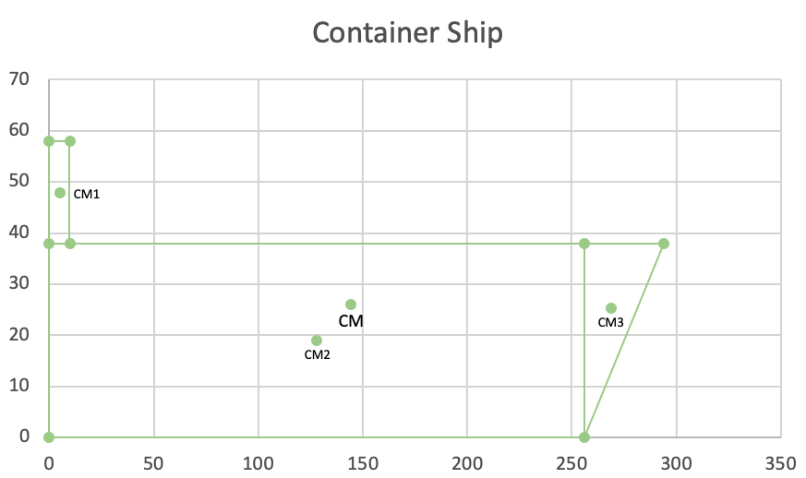

$$X_{CM}=X_{CM1}*m_{1}+X_{CM2}*m_{2}+X_{CM3}*m_{3}$$

$$=\frac{5*10000000+128.04*30000000+268.73*15000000}{55000000}$$

$$=144.04$$

$$Y_{CM}=Y_{CM1}*m_{1}+Y_{CM2}*m_{2}+Y_{CM3}*m_{3}$$

$$=\frac{47.91*10000000+18.96*30000000+25.27*15000000}{55000000}$$

$$=25.943 ≈25.94$$

$$CM(144.04 , 25.94)$$

The second one, is a Tug Ship that has multiple types, but they share the same dimensions and characteristics:

* Length: 32 m;
* Beam: 11.60 m;
* Draft: 4.29 m;
* Tare Weight: 370 tons;
* Height: 14 m;
* Cabin crew: 4m x 3m;

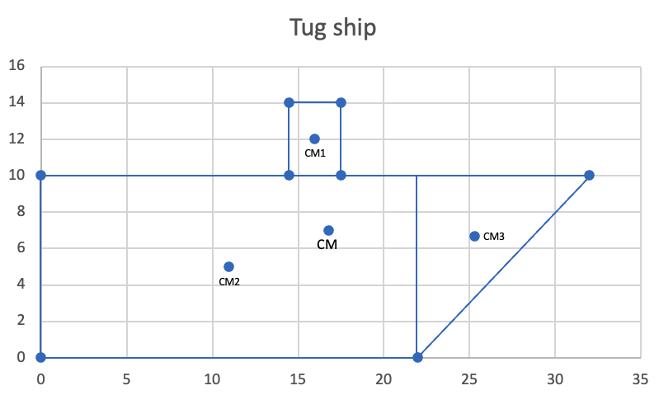

$$X_{CM}=X_{CM1}*m_{1}+X_{CM2}*m_{2}+X_{CM3}*m_{3}$$

$$=\frac{16*74000+11*172000+25.3*124000}{370000}$$

$$=16.79 ≈16.8$$

$$Y_{CM}=Y_{CM1}*m_{1}+Y_{CM2}*m_{2}+Y_{CM3}*m_{3}$$

$$=\frac{12*74000+5*172000+6.66*124000}{370000}$$

$$=6.956 ≈6.96$$

$$CM(16.8, 6.96)$$

The last one is a Ship that’s used to carry vehicles. Usually, this type of ship has the cabin crew in the bow. This one has the following dimensions:

* Length: 209 m;
* Beam: 31.84 m;
* Draft: 9.8 m;
* Tare Weight: 20000 tons;
* Height: 53.34 m;
* Cabin Crew: 10m x 5m;

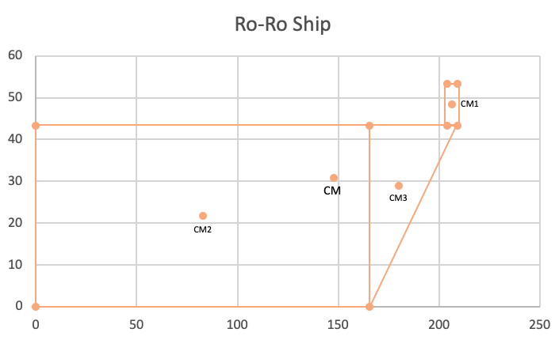

$$X_{CM}=X_{CM1}*m_{1}+X_{CM2}*m_{2}+X_{CM3}*m_{3}$$

$$=\frac{206.5*5000000+82.83*8000000+180.11*7000000}{20000000}$$

$$=147.795 ≈147.8$$

$$Y_{CM}=Y_{CM1}*m_{1}+Y_{CM2}*m_{2}+Y_{CM3}*m_{3}$$

$$=\frac{48.34*5000000+21.67*8000000+28.9*7000000}{20000000}$$

$$=30.868 ≈30.87$$

$$CM(147.8, 30.87)$$